MATHEMATICS WORKSHEET – 23 {CLASS 3RD}
Measurements
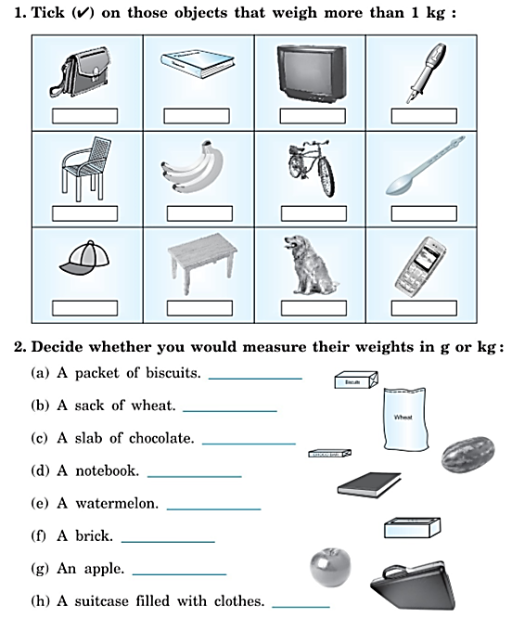
3. Subtract the Weights
